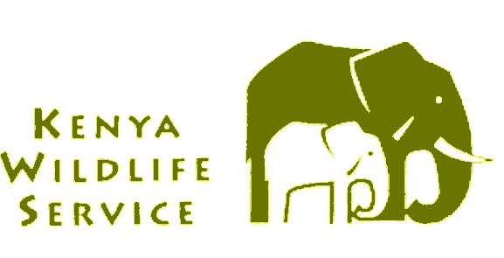

KENYA WILDLIFE SERVICE

APPLICATION FOR CAPTURE/EXPORT/IMPORT/RE-EXPORT PERMIT

Date:……………………………………………………………………………….

I/We apply for below permit and declare that all information provided is true:

Capture

Export

Import

Re-export.

Application type

CITES

Non-CITES

Details of applicant

Name ……………………………………………………………………………………………….………

……………………………………………………………………………………………………….……...

Address ………………………………………………………………………………………………….…

..……………………………………………………………………………………………………………..

………………………………………………………………….…………………………………………..

Country ………………………………………………………………………………………….………….

Details of consignee

Name ……………………………………………………………………………………………….………

……………………………………………………………………………………………………….……...

Address ………………………………………………………………………………………………….…

..……………………………………………………………………………………………………………..

………………………………………………………………….…………………………………………..

Country ………………………………………………………………………………………….………….

Details of consignor

Name ……………………………………………………………………………………………………….

.…………………………………………………………………………………………………………….

Address ………………………………………………………………….…………………………………

………………………………………………………………………………………………………………

……………………………………………………………………………………………………………….

Country …………………………………………………………………………………………….……

DETAILS OF SPECIMEN

Name of organism:

Common name……………………………………………………………………………………………

Scientific name (Genus and species) ………………………………………………………………….

- Description of part or derivative mark or numbers (give age and sex if specimen is alive).

……………………………………………………………………………………………………………….

……………………………………………………………………………………………………………….

……………………………………………………………………………………………………………….

- Quantity/number of specimen and/or net weight (kg).

…………………………………………………………………………………………………………….…

……………………………………………………………………………………………………………….

- If for re-export, give the following details:

Country of origin …………………………………………………………………………………………..

Export permit number……………………………………………………………………………………..

Date of issue……………………………………………………………………………………………….

Country of last export………………………………………………………………………………………

- Details of Import Permit issued (If applicable please give details and if not applicable state so)

Permit no……………………………………………………………………………………………………

Date…………………………………………………………………………………………………………

- Details of Certificate of Ownership issued (If applicable, please give details and if not applicable state so)

…………………………………………………………………………………………………………………………..

…………………………………………………………………………………………………………………………..

- State whether specimen was taken from:

Wild……………………………………………………………………………………………………........

Bred in captivity…………………………………………………………………………..........................

Artificially propagated……………………………………………………………………………………...

- If taken from wild, state locality and attach letter of authority.…….……………..……………………………....

…………………………………………………………………………………………………………………………..

- Details of previous application:

- Approved
- Rejected

- Name of applicant …………………………………………………………………………………………………....

Signature ………………………………………….……… Date …………………………………………………..

11. (a) Comments from Scientific Authority NMK ……………………………………………………………...

……………………………………………………………………………………………………………….
……………………………………………………………………………………………………………….

……………………………………………………………………………………………………………….

……………………………………………………………………………………………………………….

……………………………………………………………………………………………………………….

……………………………………………………………………………………………………………….

……………………………………………………………………………………………………………….

……………………………………………………………………………………………………………….

……………………………………………………………………………………………………………….

Name………………………………….. Designation………………………… Signature………………

Date…………………………..
NB: Note whether status of species is known, if non-detriment study has been conducted, verification of source and inspection of facilities as relevant and a definite recommendation as per Article IV 2(a), “that such export will not be detrimental to the survival of the species”.

- Comments from Scientific Authority KWS ……………………………………………………………...

……………………………………………………………………………………………………………….

……………………………………………………………………………………………………………….

……………………………………………………………………………………………………………….

……………………………………………………………………………………………………………….

……………………………………………………………………………………………………………….

……………………………………………………………………………………………………………….

……………………………………………………………………………………………………………….

Name………………………………….. Designation………………………… Signature………………

Date…………………………..
NB: Note whether status of species is known, if non-detriment study has been conducted, verification of source and inspection of facilities as relevant and a definite recommendation as per Article IV 2(a), “that such export will not be detrimental to the survival of the species”.

- Chief Licensing Officer’s remarks ………………………………………………………………………………..…

…………………………………………………………………………………………………………………………..

…………………………………………………………………………………………………………………………..

…………………………………………………………………………………………………………………………..

…………………………………………………………………………………………………………………………..

…………………………………………………………………………………………………………………………

Signature ………………………………….……………. Date …………………………………...………..…….
NB: To certify that the specimen are not obtained in contravention of the National Law.

- Director’s Approval/Disapproval

…………………………………………………………………………………………………………………………..

Signature ……………………………………….………. Date ………………………………………...…..…….

Note:
- Application to be submitted twenty-one (21 days) prior to exportation or importation.
- Original document as per 4 to 7 above to be attached to this application.
3. Approval for all import MUST BE granted prior to the actual importation.

